**Phase 1 – GanttProject**

**Factory Method Pattern**

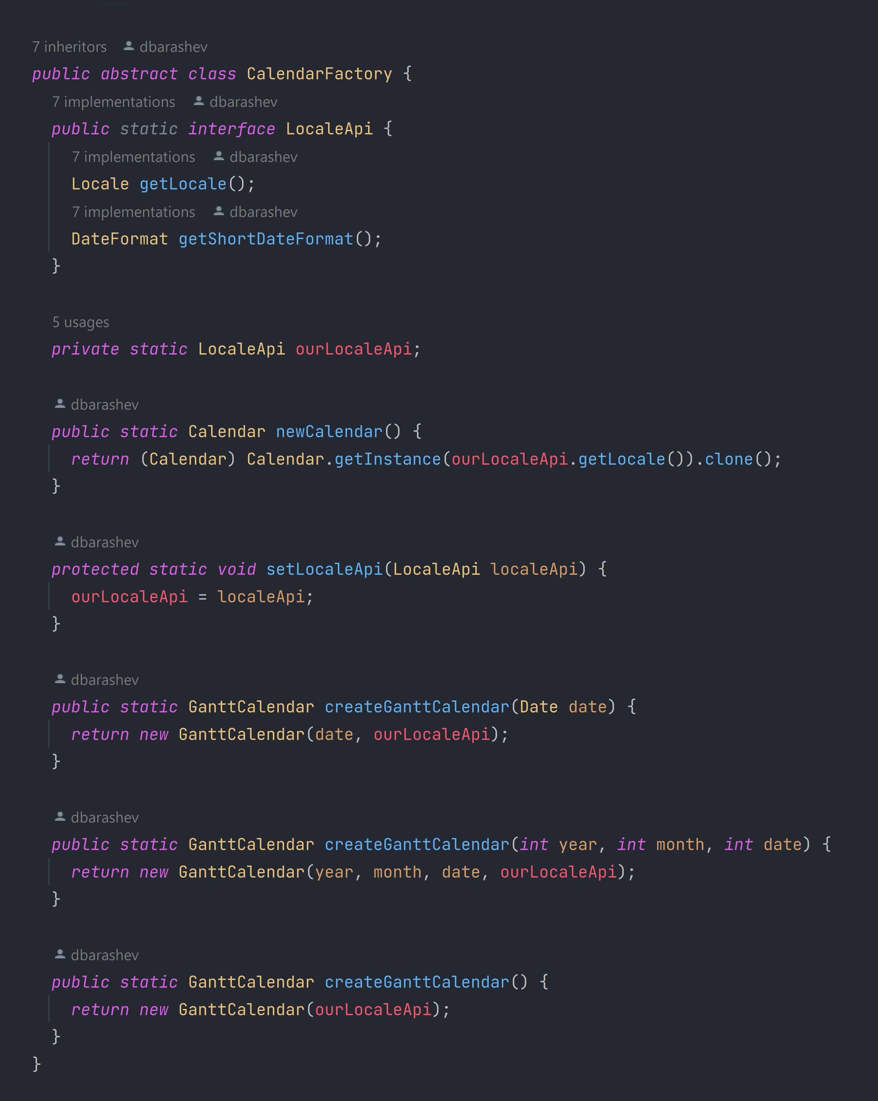biz.ganttproject.core.time.CalendarFactory

This is a Factory Method design pattern because it hides the creation of instances of the class GanttCalendar behind a factory class CalendarFactory.

* **Product Object:** GanttCalendar

The object type varies depending on the *Locale,* insteadof having subclasses.

The way to specify the product object type here is by setting the *Locale* (via the setLocaleApi method).

* **Factory Object:** CalendarFactory
* **Factory Method:** createGanttCalendar

It’s a static method, so that, even though CalendarFactory isn’t a singleton, the methods may be called directly from the factory object.

**Adapter Pattern**

net.sourceforge.ganttproject.task.event.TaskListenerAdapter

This is an Adapter design pattern because it provides a compatible interface between the event handling services and the client that wants to adapt the handling of events to its needs, which would be incompatible otherwise.

* **Adapter class:** TaskListenerAdapter
* **Target interface:** TaskListener

net.sourceforge.ganttproject.task.event.TaskListener

An example of a client class that uses this adapter class to adapt the handling of events is TaskManagerImpl.

net.sourceforge.ganttproject.task.TaskManagerImpl

**Façade Pattern**

net.sourceforge.ganttproject.task.CustomColumnsManager

This is a Façade design pattern because it provides a unified interface to a subsystem (the subsystem of classes handling “custom properties”) hiding its complexity, and provides a point of entry to it: the CustomColumnsManager class.

* **Façade class:** CustomColumnsManager
* **Interfaces it provides access to:** CustomPropertiesDefinition and CustomPropertyListener (using methods like *addNewCustomColumn*, *addListener*, to name a few)

net.sourceforge.ganttproject.task.CustomColumn

net.sourceforge.ganttproject.DefaultCustomPropertyDefinition

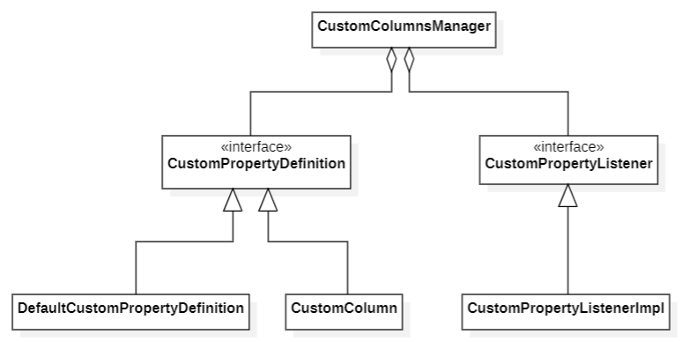

An excerpt of the classes that make up this design pattern